Lambda function -29th August

1. Create two instance (Prodserver01/02) on EC2 server

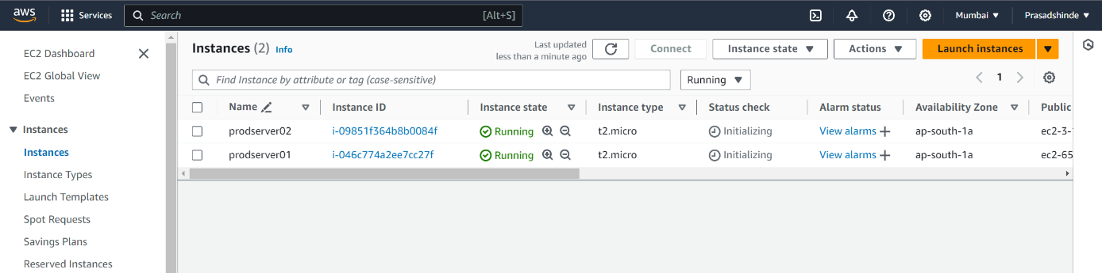

2.Add tag for one instance

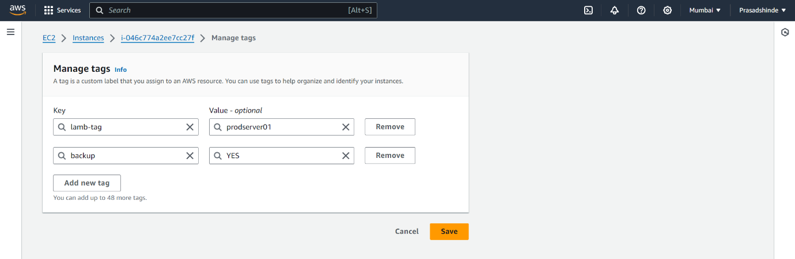

3.Create a IAM role for lambda service(ebs-volume-backup-role )

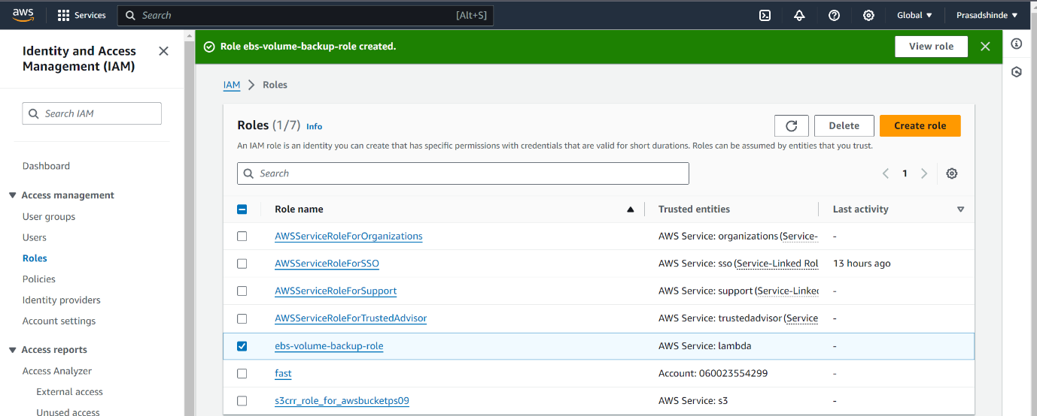

4.while creating lambda fuction select a common scripting language and add role

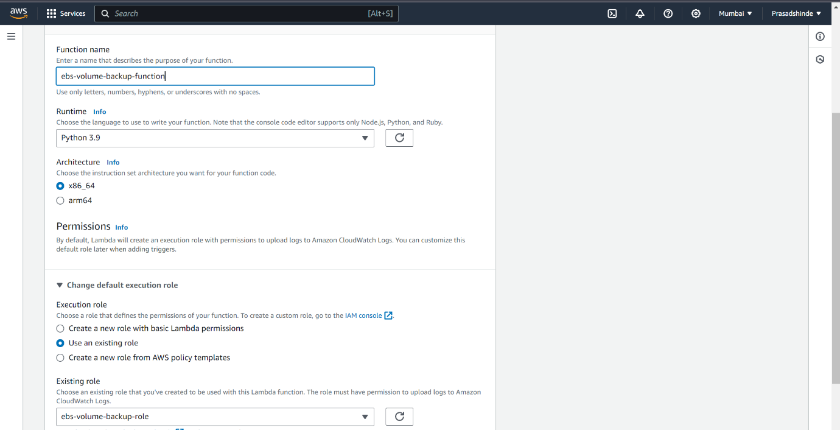

5.Create the function

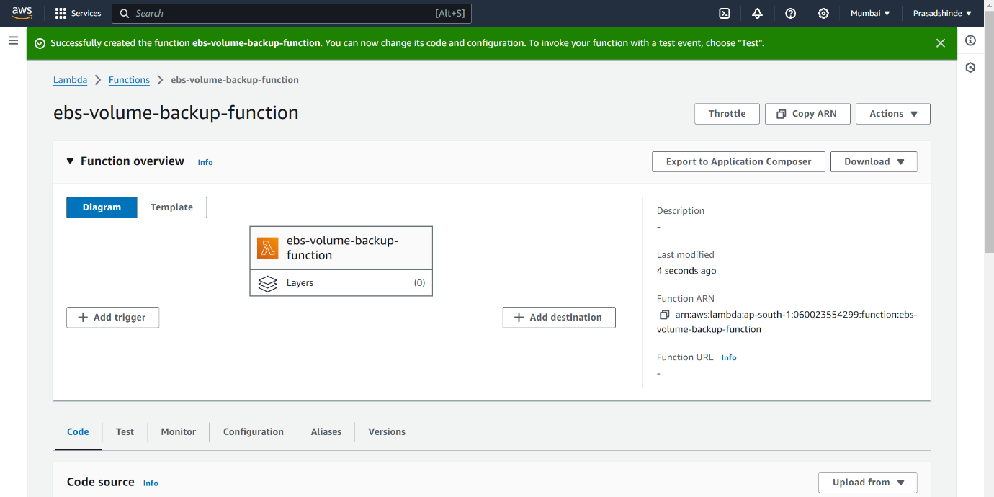

6. Deploy the code

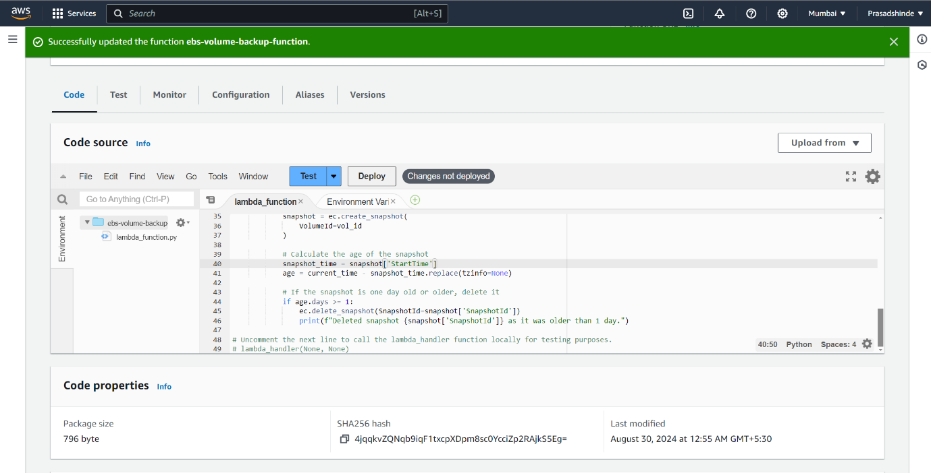

7. Test event for run the code

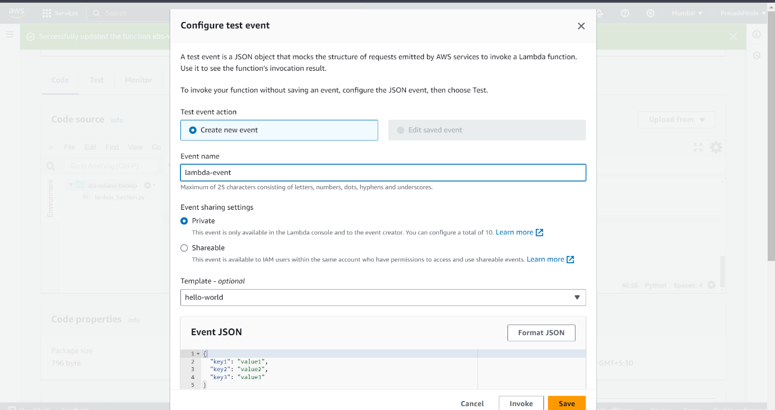

8.sanpshot is created

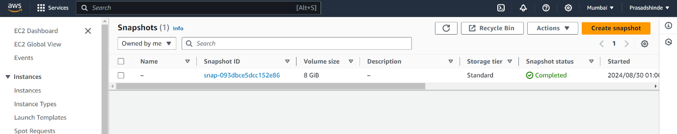

9.Create trigger for each minute

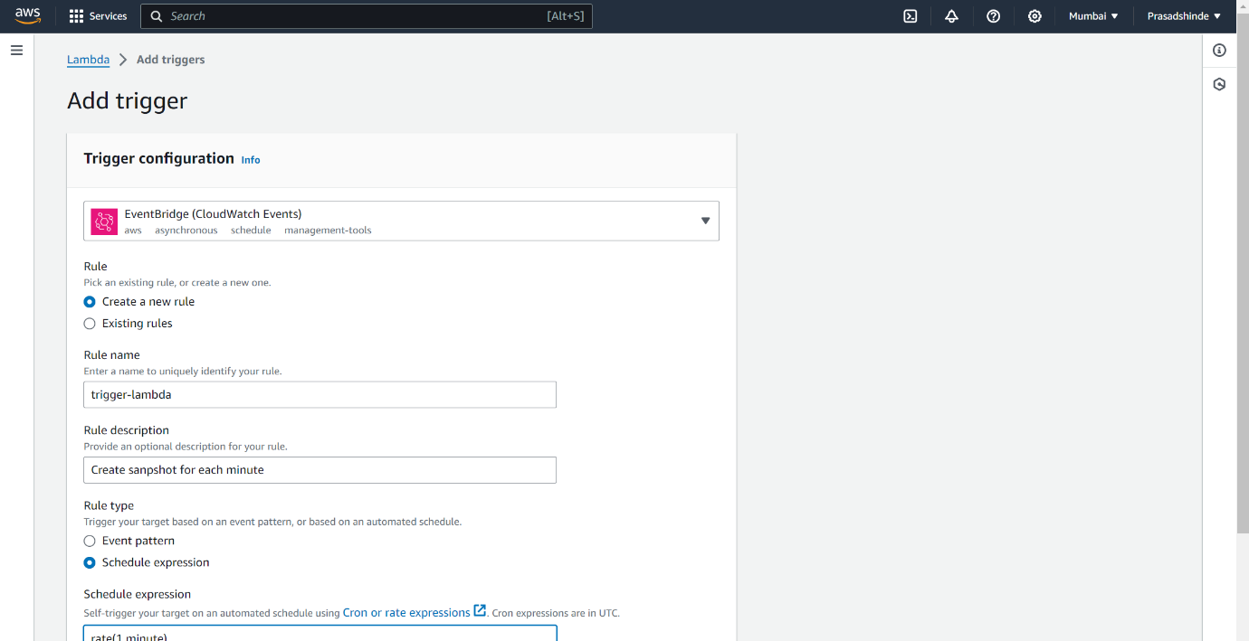

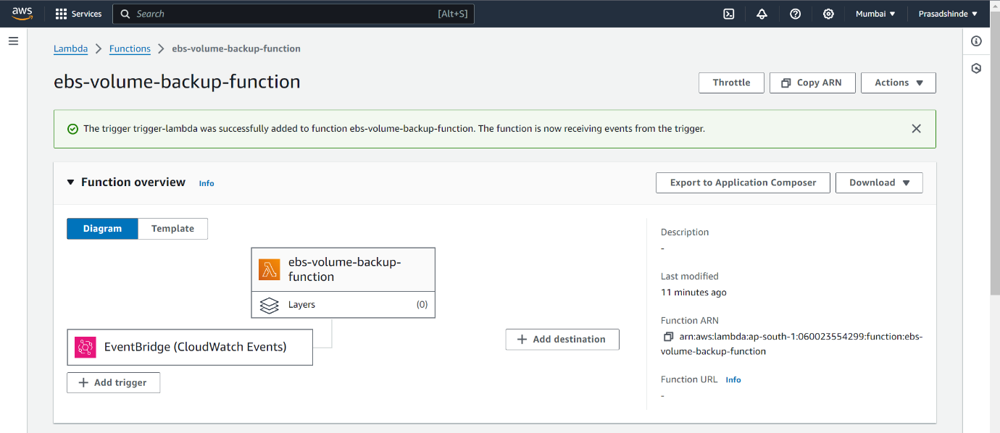

10. sanpshot is created for every one minute

